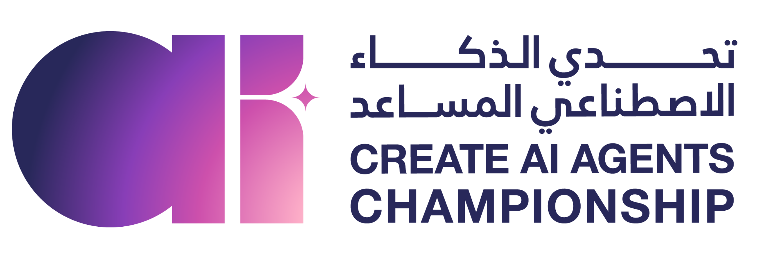

Workshop 1 · My checked AI task
  - Submission template · upload to the shared folder
Field | Your answer
Name
Track (A assistant prompt / B agent system prompt)
Date | 21 October 2026

1. Prompt V1
Paste your first prompt exactly as you ran it.

2. Initial score
Total /14 from the prompt scorer, and the two weakest criteria.

3. Prompt V2 · final version
Paste your improved prompt.

4. Outputs of V2
Paste the full output for message 4, then for message 5.

5. Checklist on the V2 outputs
Tick each check for each output. Leave it empty if the output fails it.
Check | Message 4 | Message 5
Every fact has a source (the message or an approved reference).
No missing information is invented.
No forbidden promise: refund, amount, deadline.
No action is claimed that was not performed (sent, logged, notified).
Personal data is minimised.
The draft and the human decision are explicit.

6. Final score
Total /14 from the same scorer.

7. What changed and why
One or two sentences: the defect you found in V1's output, its evidence, and the rule you added in V2.

Score per criterion (optional)
Criterion | V1 | V2
Goal
Context
Knowledge
Tools
Actions
Checks
Output
Total /14

Use fictional or anonymised content only. A higher score shows a clearer prompt; the checklist shows whether the output itself is safe to use.

